Design Doha Announces Mexico Edition of Crafting Design Futures Residency and 2026 Participants

Four designers from Qatar and the wider MENASA region collaborate with Mexican artisans through the Years of Culture partnership with Mexico

DOHA, 30 SEPTEMBER 2026: Design Doha announced the return of its international residency programme, Crafting Design Futures, with four designers from Qatar and the wider Middle East, North Africa, and South Asia (MENASA) region selected to work alongside Mexican master artisans as part of the 2026 Year of Culture partnership between Qatar and Mexico.

Building on the inaugural edition launched during the Qatar-Morocco 2024 Year of Culture, Crafting Design Futures will bring together designers and artisans as collaborators, using research, experimentation and shared making to explore what inherited craft knowledge can bring to contemporary design.

Working within family-run workshops and gaining insight into techniques passed down through generations, the participating designers in the residency explore how inherited techniques can take on new forms through contemporary design. From ancestral engraving to the hand-hammered copper of Santa Clara del Cobre, the programme considers how traditional knowledge continues to evolve through creative exchange.

The resulting works will be presented from 8 October - 1 November as part of Design Week Mexico’s Visión y Tradición programme exhibition at the National Museum of Anthropology in Mexico City. Visión y Tradición is a platform established by Design Week Mexico and Mexico Territorio Creativo that connects contemporary designers with artisan communities across Mexico through research, collaboration and cultural exchange. The programme supports the visibility of traditional knowledge while creating new cultural, professional and creative connections.

Commenting on the programme, Fahad Al Obaidly, Director of Design Doha, said, “The success of our first residency with Morocco showed us that the most meaningful design happens when people create together and learn from one another along the way. Through our partnership with Years of Culture, we’re building a global network of designers and artisans who exchange knowledge, challenge perspectives and form relationships that inspire a new generation of design – exactly the type of lasting impact Years of Culture is designed to create.”

The 2026 Pairings
This year’s four collaborations span mediums including clay, engraving, ceramics and metalwork, and hand-hammered copper. Each pairing explores what can happen to traditional knowledge when it encounters contemporary design, how an inherited technique can take on a new form, and how designers can honour an original craft without simply reproducing it.

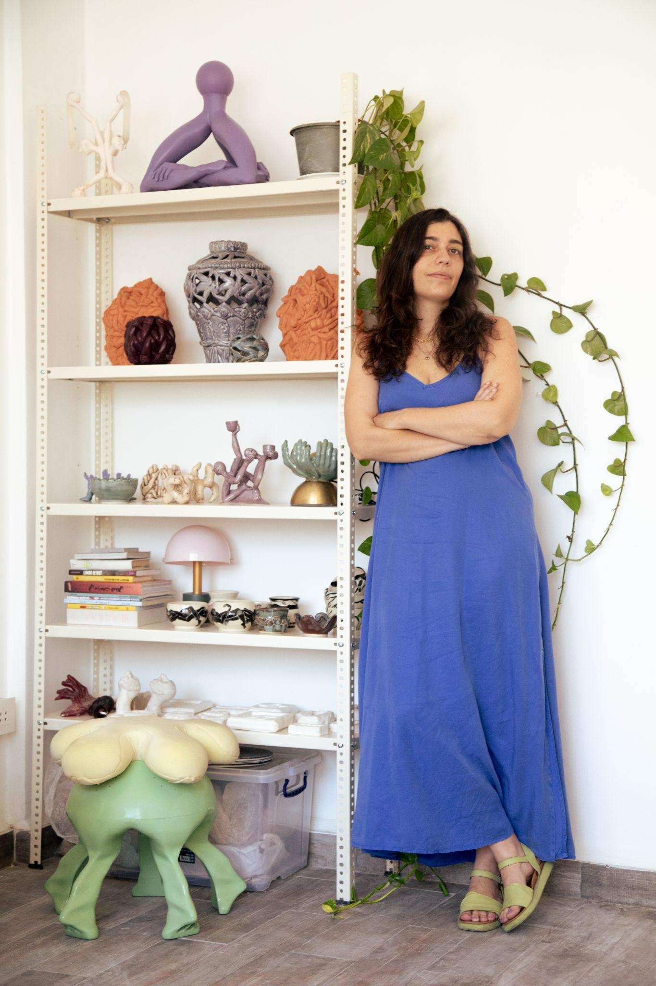
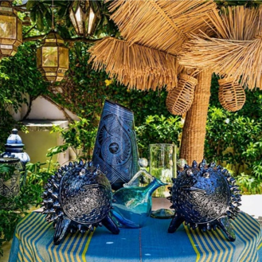

Shirine Sbaiti × Norberto y Rosi — Uruapan, Michoacán
Lebanese designer and multidisciplinary artist Shirine Sbaiti, known through her artistic practice LimbObject (Limbo) which uses human limbs as structural and aesthetic elements to create objects, is working with Norberto y Rosi. Sbaiti's own practice moves between functional objects, figurative sculpture and illustration, whereas Norberto y Rosi’s handcrafted clay works preserve sgraffito, a technique involving the scratching or carving through an upper layer of pigment to reveal a contrasting color or raw material, and painted-clay traditions rooted in Mexican community histories, making the collaboration a meeting of two different approaches to storytelling through clay.
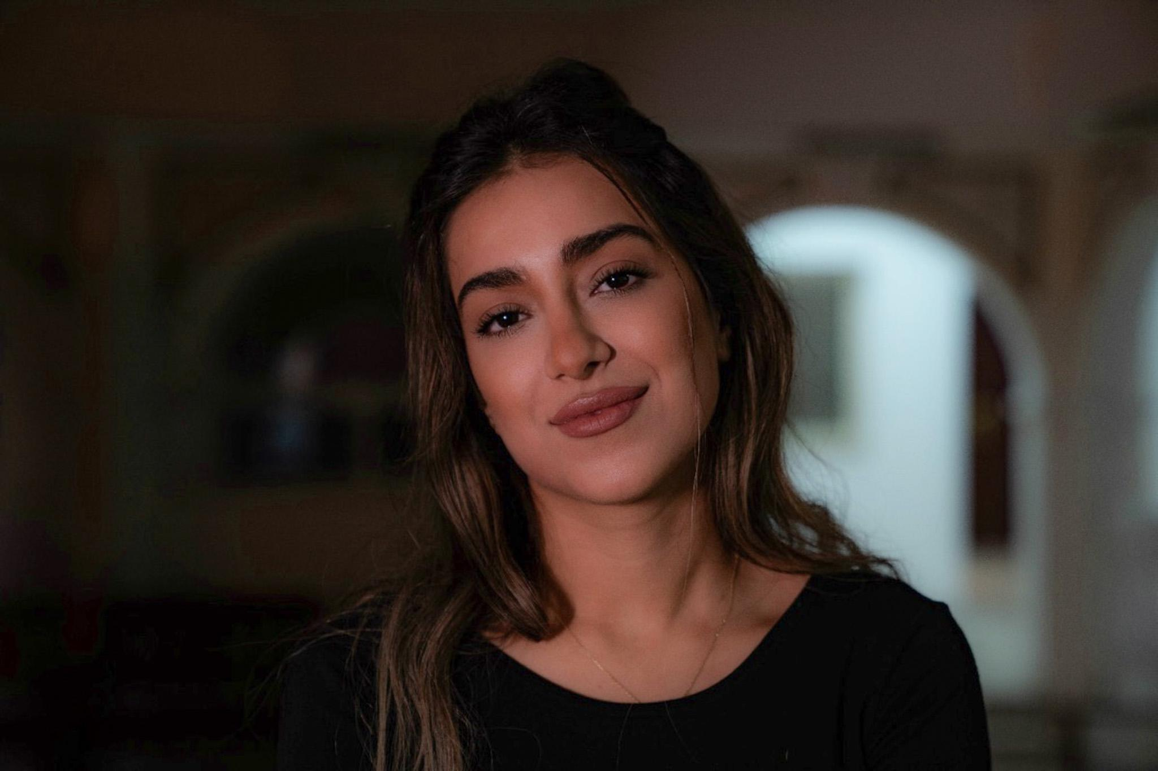
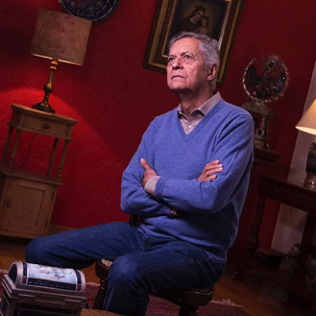

Yasamin Shaikhi × Estudio Guerrero — Guadalajara, Jalisco
Qatar-based Iranian interdisciplinary designer Yasamin Shaikhi, whose practice explores material innovation, memory, and the transformation of overlooked materials, has partnered with Estudio Guerrero, known for combining glazed, majolica-type ceramic with ornamental alpaca, or white metal, applications.

Shaikhi's research-led approach treats materials as active participants in the design process, an approach she shares with the Guadalajara practice that’s developed its own material language by combining ceramic and metal.

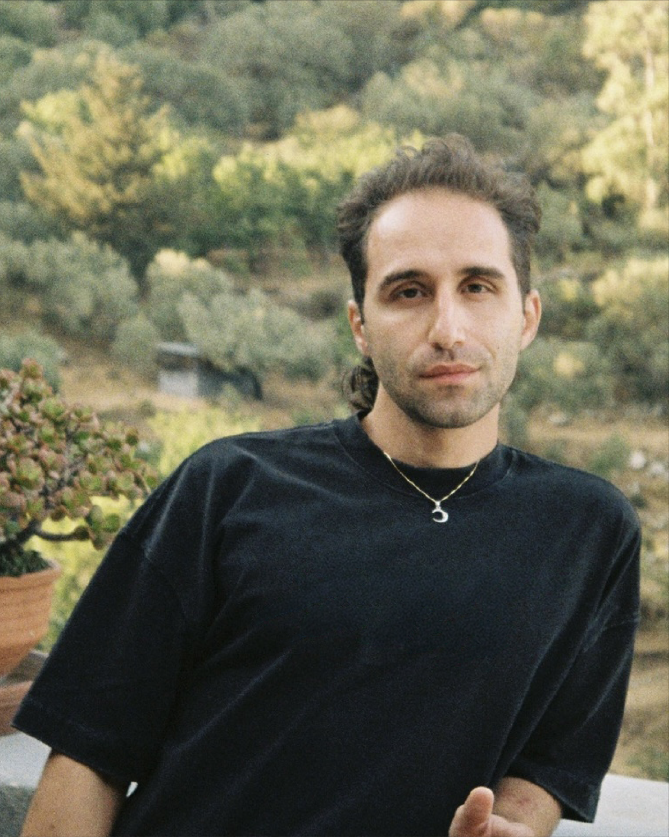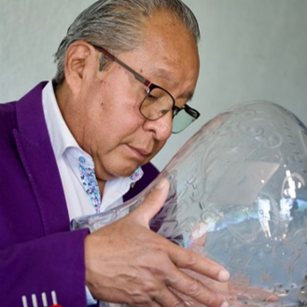
Kenan Alkuwatly × José Cruz — Xochimilco, Mexico City
Syrian multidisciplinary designer Kenan Alkuwatly is working with master engraver José Cruz, a specialist in the ancestral Mexican technique of pepita engraving, a traditional Mexican hand-carving technique dating back to the 16th century in which small, decorative, seed-like indentations are pressed into glassware. Cruz began learning the craft at the age of 12 in his father’s and uncle’s workshops and was considered a master engraver by 17. Alkuwatly's own practice draws on the architecture, ornament, and material culture of the Arab world as ways of carrying history into contemporary design. His collaboration with Cruz brings together two different cultural traditions around a shared idea: that an object can hold memory.

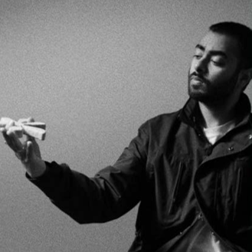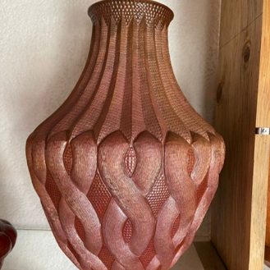

Armaan Bansal × Alan Pureco — Santa Clara del Cobre, Michoacán
British-Indian architect, designer, and creative director Armaan Bansal is collaborating with Alan Pureco’s family workshop, which represents more than three generations of copper craftsmanship in Santa Clara del Cobre, a town renowned for its hand-hammered copper tradition. Bansal's practice similarly looks at how inherited craft and materials can inform contemporary objects without losing their cultural specificity.

Abdulrahman Al Muftah, a Qatari designer who took part in the inaugural Crafting Design Futures residency with Morocco and now supports current participants, said: “The residency in Morocco showed us that preserving craft does not mean keeping it unchanged. When knowledge passed down through generations is shared with another maker, it can lead to something entirely new. In Mexico, we are continuing that exchange and looking at craft as living knowledge, something that can evolve, inspire and shape the future of design.”

-ENDS-

ABOUT QATAR MUSEUMS
Qatar Museums (QM), the nation’s preeminent institution for art and culture, provides authentic and inspiring cultural experiences through a growing network of museums, heritage sites, festivals, public art installations, and programmes. QM preserves and expands the nation’s cultural offerings, sharing art and culture from Qatar, the Middle East, North Africa, South Asia (MENASA), and beyond with the world and enriching the lives of citizens, residents, and visitors.

Under the patronage of His Highness the Amir, Sheikh Tamim bin Hamad Al Thani, and led by its Chairperson, Her Excellency Sheikha Al Mayassa bint Hamad bin Khalifa Al Thani, QM has made Qatar a vibrant centre for the arts, culture, and creative exchange in the Middle East and beyond. QM is integral to the mission of developing an innovative, diverse, and progressive nation, bringing people together to ignite new thinking, spark critical cultural conversations, and amplify the voices of Qatar’s people. Since its founding in 2005, QM has overseen the development of museums including the Museum of Islamic Art (MIA) and MIA Park, Mathaf: Arab Museum of Modern Art, the National Museum of Qatar (NMoQ), 3-2-1 Qatar Olympic and Sports Museum, ALRIWAQ Art + Architecture, and QM Gallery Katara. Future institutions include Dadu, Children’s Museum of Qatar, the Art Mill Museum, the Qatar Auto Museum, and the Lusail Museum.

Through its Creative Hubs and recurring festivals and biennials, such as M7, Fire Station, Liwan Design Studios and Labs, the Tasweer Qatar Photo Festival, and Design Doha, QM initiates and supports projects that nurture artistic talent and create opportunities to build a strong and sustainable creative infrastructure.

It is within this spirit of growth and ambition that QM proudly celebrates Evolution Nation, a campaign honouring Qatar's cultural journey over the past 50 years, since the original founding of the National Museum of Qatar. Curated by Qatar Creates, Evolution Nation highlights both the nation's cultural milestones and its bold aspirations for the future.

Animating everything that QM does is an authentic connection to Qatar and its heritage, a steadfast commitment to inclusivity and accessibility, and a belief in creating value through invention.

For more information visit https://qm.org.qa.

ABOUT DESIGN DOHA
Established in 2024 by Her Excellency Sheikha Al Mayassa bint Hamad bin Khalifa Al Thani, Chairperson of Qatar Museums, Design Doha is a premier international design biennial celebrating contemporary design, innovation, and creativity in the MENASA (Middle East, North Africa and South Asia) region and beyond. Presented across multiple venues and public spaces, and in collaboration with leading regional and international institutions, Design Doha serves as a global platform for exhibitions, installations, awards, public design commissions, and special events, connecting MENASA designers with industry leaders and visionaries from around the world. Fahad Al Obaidly serves as Director, with Glenn Adamson as Artistic Director.

The opening days of Design Doha Biennial 2026 will take place from 5–7 November 2026. Exhibitions will remain on view from 5 November 2026 to 31 January 2027.

FIND US ONLINE:
Qatar Museums
X: @Qatar_Museums | Instagram: @Qatar_Museums | Facebook: @QatarMuseums

Design Doha
Instagram: @designdohabiennial
Website: https://designdoha.org.qa/en/

Media Contact:

Mohammed Khamis Al Abdulla
mfaraj@qm.org.qa
+974 5592 0088

Joelyn Baluyut
jbaluyut@qm.org.qa
+974 6647 4036

About Years of Culture
The Years of Culture initiative, chaired by Her Excellency Sheikha Al Mayassa bint Hamad bin Khalifa Al Thani, spearheads long-lasting cultural partnerships between Qatar and other nations. It exists to promote respect and understanding among diverse cultures and serves as a catalyst for bringing people together, nurturing connections, encouraging dialogue, and deepening understanding. At its core, Years of Culture is a portal for making connections across various sectors, including cultural heritage, creative industries, social and economic development, and innovation, which enriches Qatar’s ties with partner countries beyond the dedicated year.

Each year is organised with support from Qatar and partner countries’ cultural institutions, ministries, foundations, and private and public sector partners, with assistance from Embassies in Qatar and abroad. Programmes are tailored to explore the unique nature of each partner country.

Previous Years of Culture have included: Qatar-Japan 2012, Qatar-UK 2013, Qatar-Brazil 2014, Qatar-Türkiye 2015, Qatar-China 2016, Qatar-Germany 2017, Qatar-Russia 2018, Qatar-India 2019, Qatar-France 2020, Qatar-USA 2021, Qatar-MENASA 2022, Qatar-Indonesia 2023, Qatar-Morocco 2024, and Qatar Argentina and Chile 2025.

FIND US ONLINE:
Years of Culture
Website: yearsofculture.qa
X: @YearsofCulture | Instagram: @YearsofCulture | Facebook: @YearsofCulture

PRESS CONTACT:
Anya Kotova
Years of Culture
akotova@qm.org.qa

